
Submitted by : Spogmai Jan
Roll no : 2430 -0081
Submitted to : mam yusra

Dsa lab 04:
Task 01: Create a class that contains a single integer field, temperature. Define a constructor that take no
parameters. The temperature field should be set to the value 15 in constructor. Define the
mutators (setter) for warmer and cooler method, whose effect is to increase or decrease the value
of the temperature by 5 respectively. Define an accessor (getter) to return the value of temperature.
#include <iostream>
using namespace std;

class Temperature {
private:
int temperature;

public:
Temperature() {
temperature = 15;
}
void warmer() {
temperature += 5;
}
void cooler() {
temperature -= 5;
}
int getTemperature() {
return temperature;
}
};

int main() {
Temperature t;

cout << "Initial Temperature: " << t.getTemperature() << endl;

t.warmer();
cout << "After Warmer: " << t.getTemperature() << endl;

t.cooler();
cout << "After Cooler: " << t.getTemperature() << endl;

return 0;
}

Output:
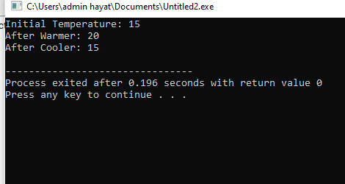

Task 02: Task 02: Write the outputs and find errors if any.
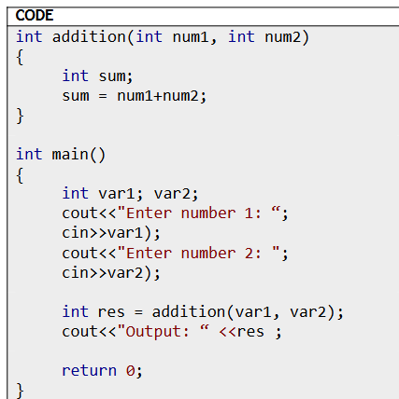
#include <iostream>
using namespace std;

int addition(int num1, int num2)
{
int sum;
sum = num1 + num2;
return sum;
}

int main()
{
int var1, var2;
cout << "Enter number 1: ";
cin >> var1;

cout << "Enter number 2: ";
cin >> var2;

int res = addition(var1, var2);
cout << "Output: " << res;

return 0;
}
Output:
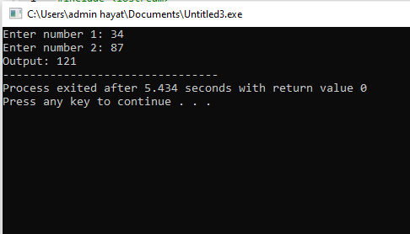
------------------------------------------

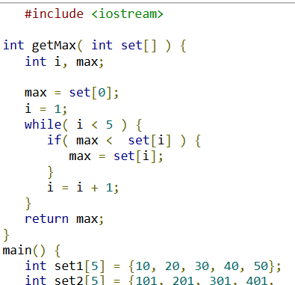
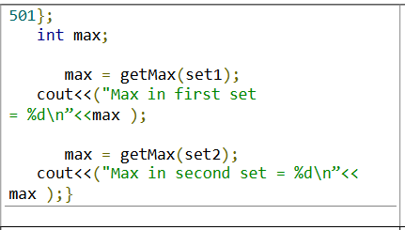
#include <iostream>
using namespace std;

int getMax(int set[]) {
int i, max;
max = set[0];
i = 1;
while (i < 5) {
if (max < set[i]) {
max = set[i];
}
i = i + 1;
}
return max;
}

int main() {
int set1[5] = {10, 20, 30, 40, 50};
int set2[5] = {101, 201, 301, 401, 501};
int max;

max = getMax(set1);
cout << "Max in first set = " << max << endl;

max = getMax(set2);
cout << "Max in second set = " << max << endl;

return 0;
}
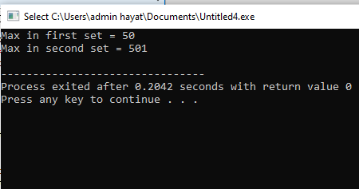
---------------------------------------
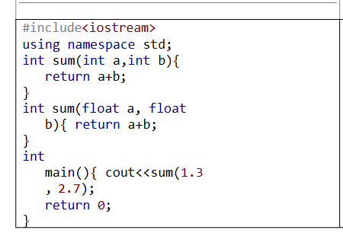
#include <iostream>
using namespace std;

int sum(int a, int b) {
return a + b;
}

int sum(float a, float b) {
return a + b;
}

int main() {
cout << sum(1.3, 2.7);
return 0;
}

Output:
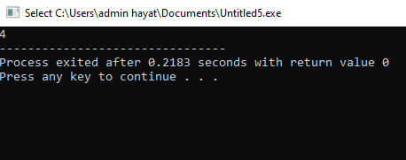
Task 03: Write a C++ program to find factorial of a numbers (10-1) using recursion .
#include <iostream>
using namespace std;

int factorial(int n) {
if (n == 1) // Base case
return 1;
else
return n * factorial(n - 1); // Recursive call
}

int main() {
for (int i = 10; i >= 1; i--) {
cout << "Factorial of " << i << " = " << factorial(i) << endl;
}
return 0;
}

Output:
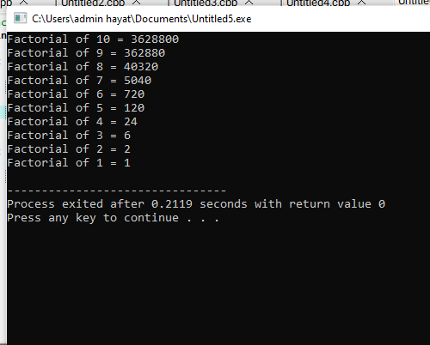
Task 04: Write a C++ program to print nth terms value in Fibonacci series using recursion.
#include <iostream>
using namespace std;

int fibonacci(int n) {
if (n == 0) // Base case 1
return 0;
else if (n == 1) // Base case 2
return 1;
else
return fibonacci(n - 1) + fibonacci(n - 2); // Recursive call
}

int main() {
int n;
cout << "Enter the term number (n): ";
cin >> n;

cout << "The " << n << "th term in Fibonacci series is: " << fibonacci(n) << endl;
return 0;
}
Output:
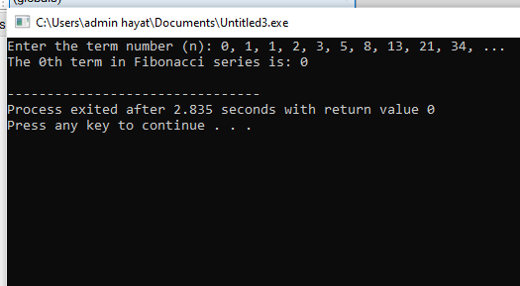
---------- The End--------

